A guide to setting-up your B&FC Admissions Portal
(Click on the relevant question)

- How do I access my B&FC Admissions Portal?
- How do I view my applications?
- How do I update my contact details?
- How do I upload evidence of qualifications or other documents relevant to my application?

- How do I update my personal details?
- How do I view and update my interviews?
- How do I view and accept my offers?
- How do I view and update funding information?
- How do I view my work placement information?

How to Access your B&FC Admissions Portal

To access your B&FC Admissions portal go https://blackpool.powerappsportals.com/
At the following screen enter your details.
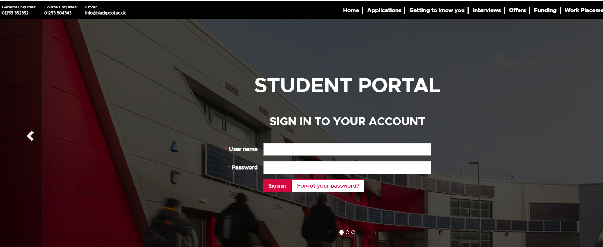

When you have logged into the portal you will be taken to your profile page as follows:
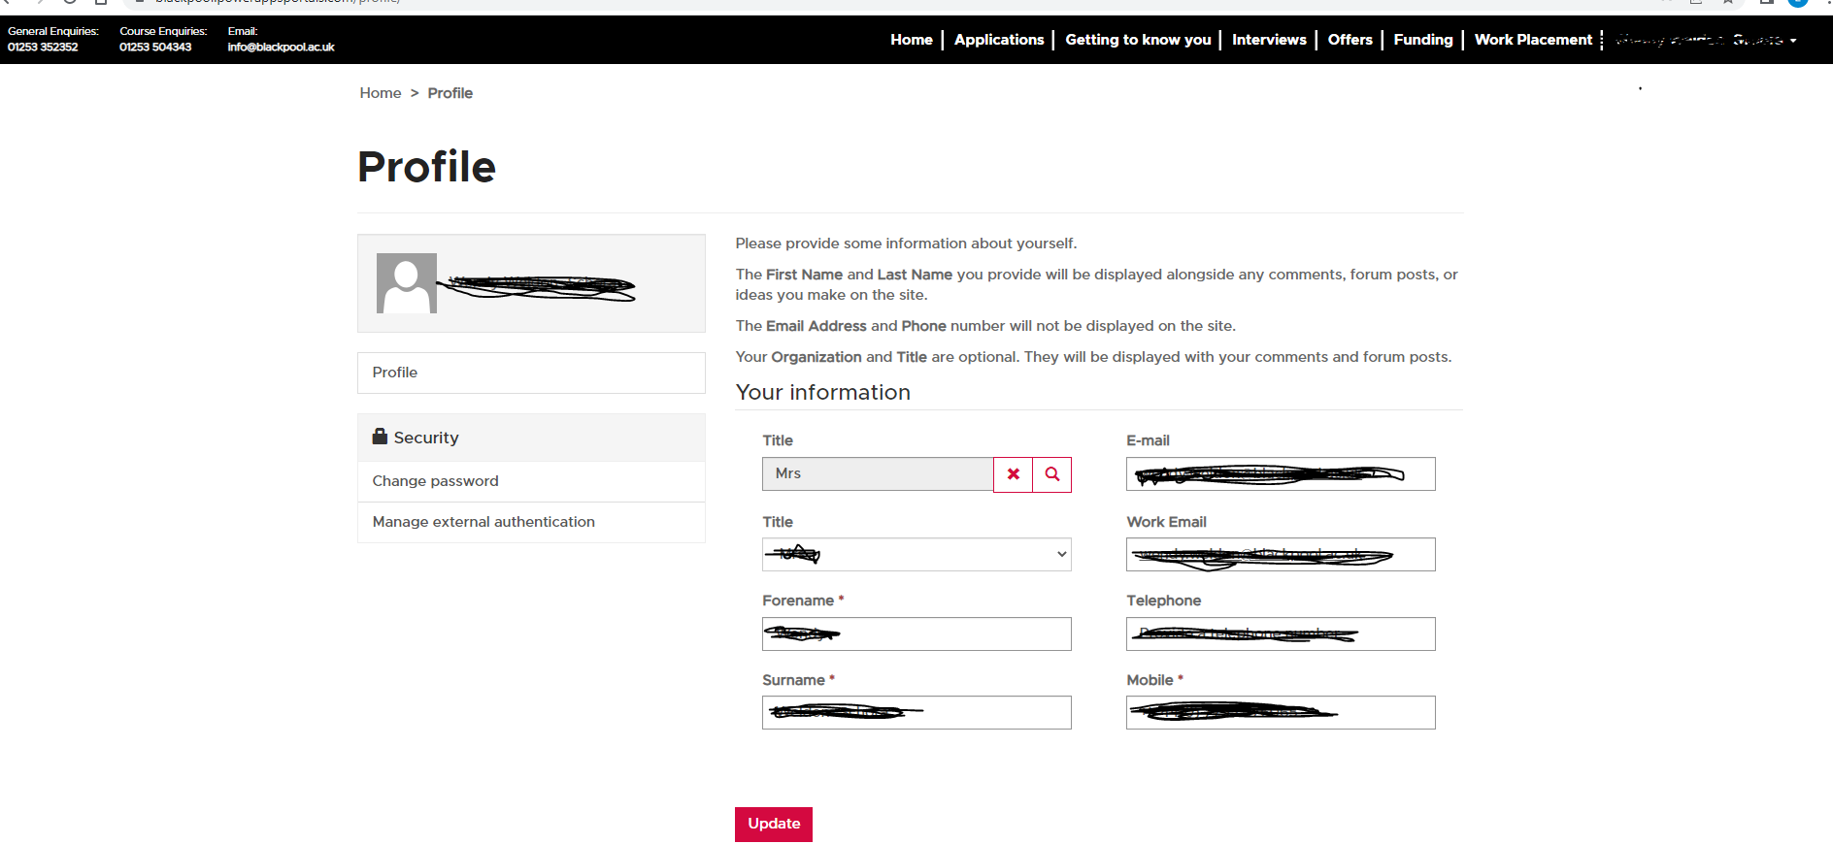

From the top of the menu at the top of this page click on applications and you will be taken to the following page.

How to view your applications
(the following view can always be accessed by clicking Applications from the top menu bar)
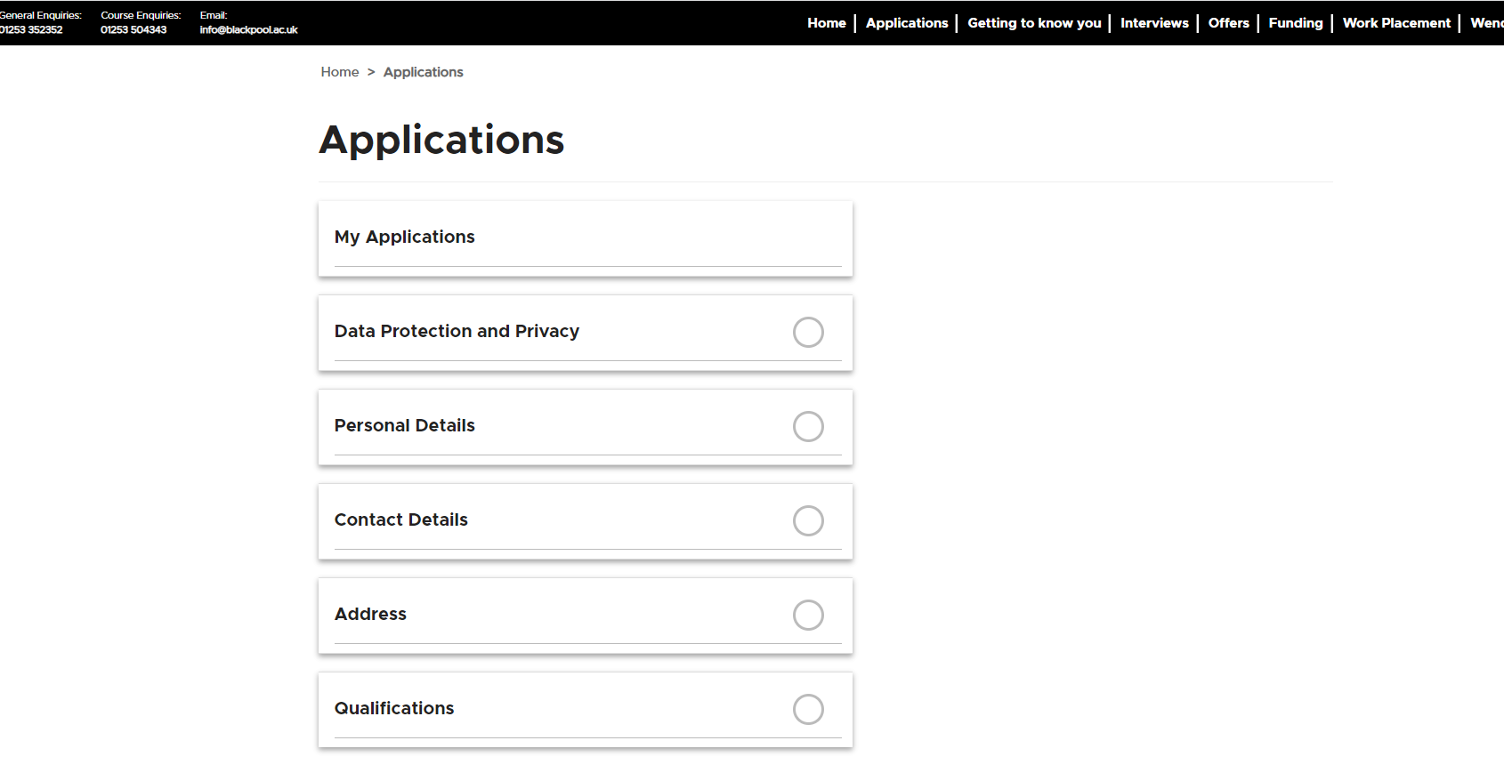
From this menu you can also view your applications, update your details or qualifications by clicking on the relevant option on the menu in the list.
By clicking on My Applications you will see a full list of your applications as follows:
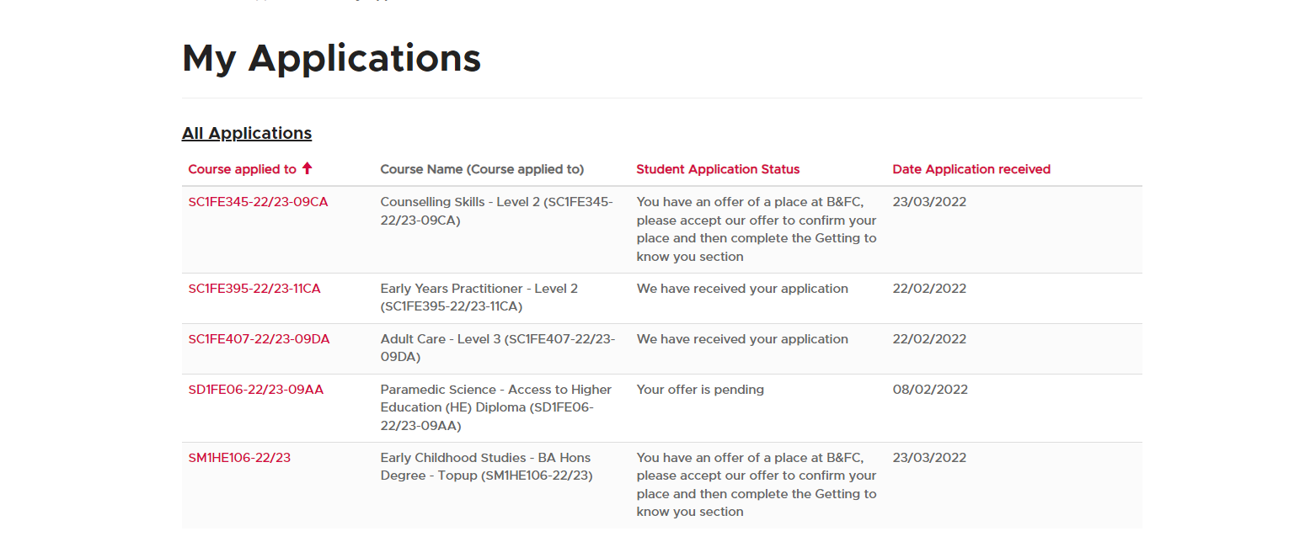

From this list you click on the course code, highlighted in red on the left-hand side of the screen and you will be able taken to the Application Details screen where you can see the status of relevant application.
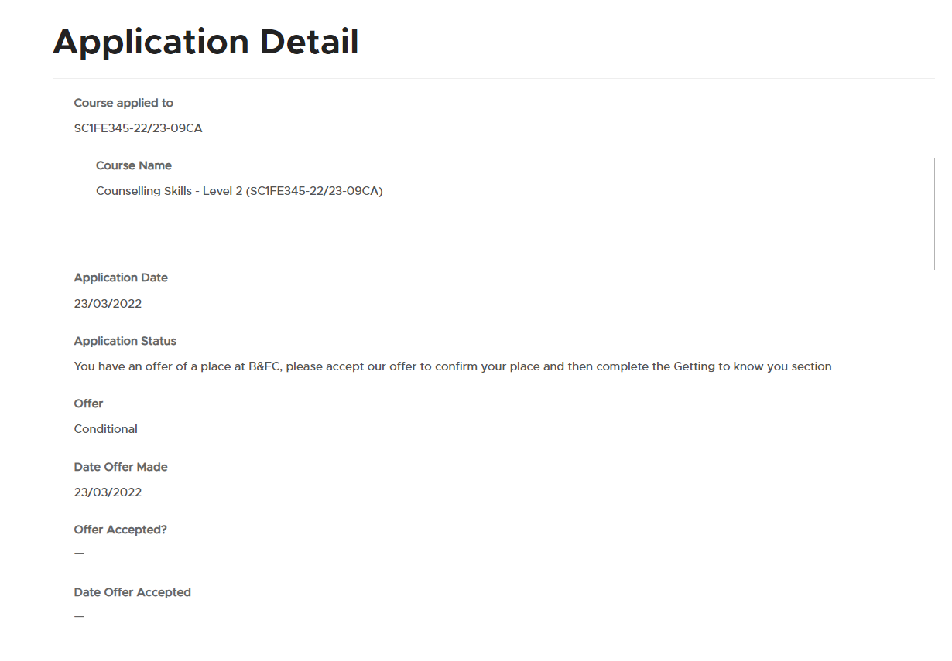

How to update contact details

Go to the menu at the top of the page and click on Applications you will then be directed to the following screen where you can click on personal or contact details, and update and save your new details.

How to update evidence of qualifications or other documents relevant to your application

Go to the menu at the top of the portal web page and click on Applications you will then be directed to the follow page. From the menu on this page click on qualifications. At the top of this page there is an area for you to enter details of your qualifications.
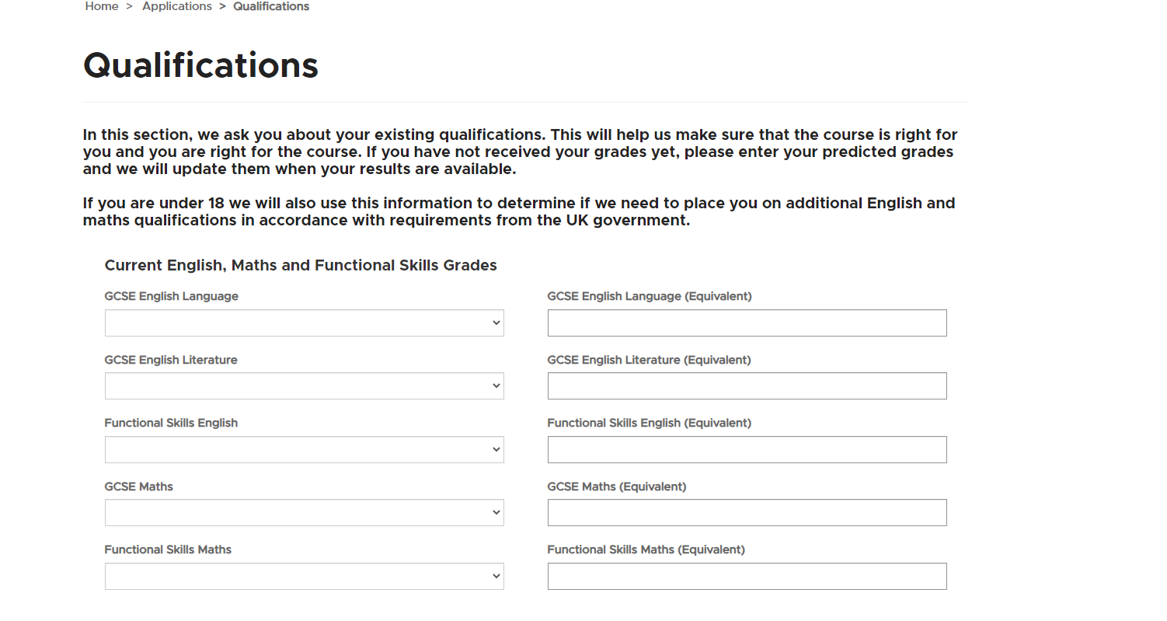

If you scroll further down the page past Additional Qualifications to File Upload, here you can upload documents for example evidence of qualifications or other documents to support your application.
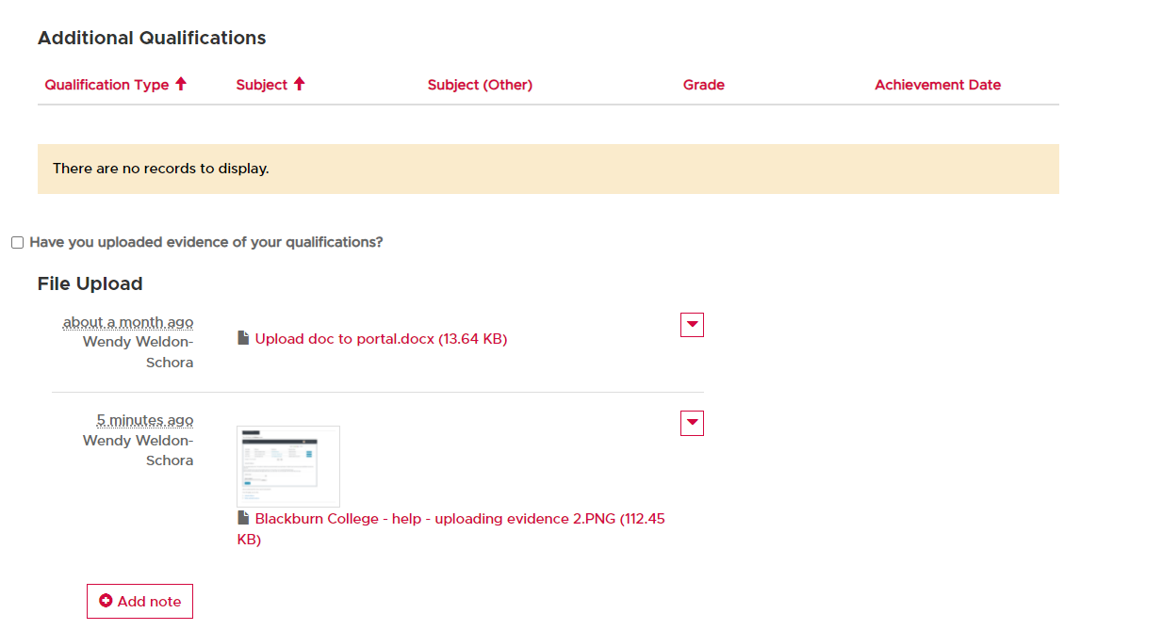

You can upload your documents by clicking on the Add note button. You will then be taken to the following page:

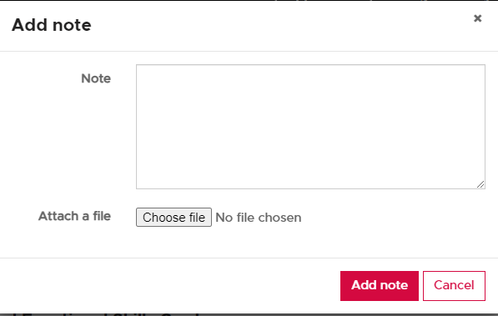

Click on choose file, will you will be taken to your files, click on the file you want to upload, from the file dialogue box click the open button at the bottom right of the box. You will then be directed back to the page above, click on the add note button and your file will be uploaded and will be listed in your file uploads on the Qualifications page.

Getting to know you

To view this page from the menu at the top of the screen click on “Getting to know you”.
The following screen will appear, here you can click onto the relevant headings and update your information.
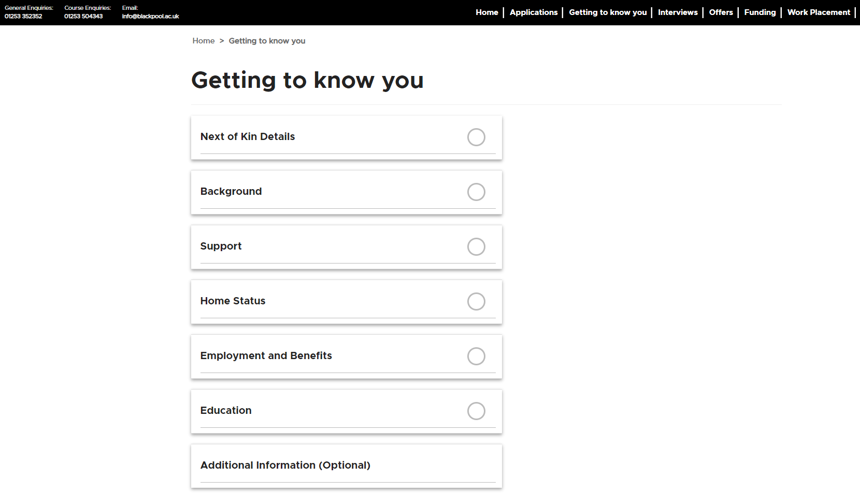

How to view and update your interviews

Go to the menu at the top of the portal web page and click on Interviews you will then be directed to the follow page where you can view all the interviews you have booked.
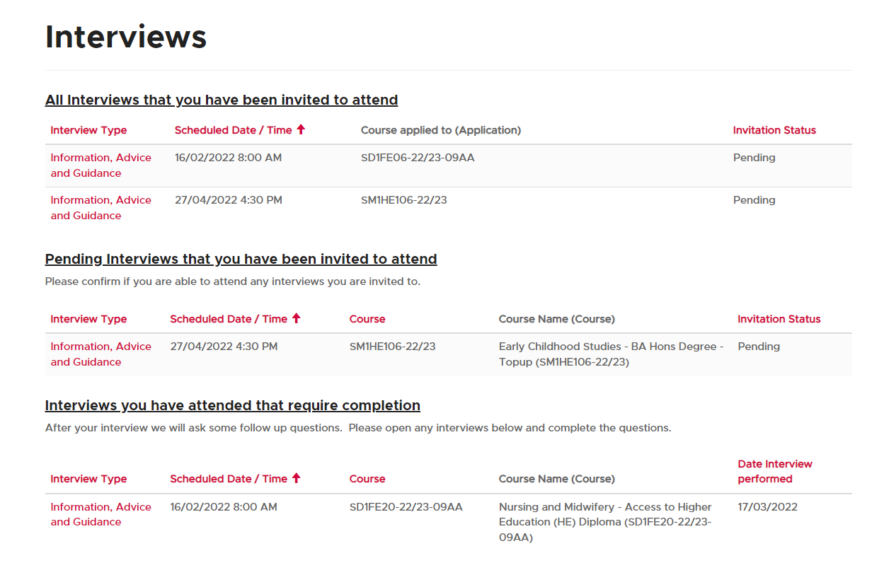

If you would like to confirm attendance or request for a change of date you can do this by clicking on the interview type for the relevant interviews (the text in red on the left-hand side of the screen). When you click here you will be taken through to the interview detail page:
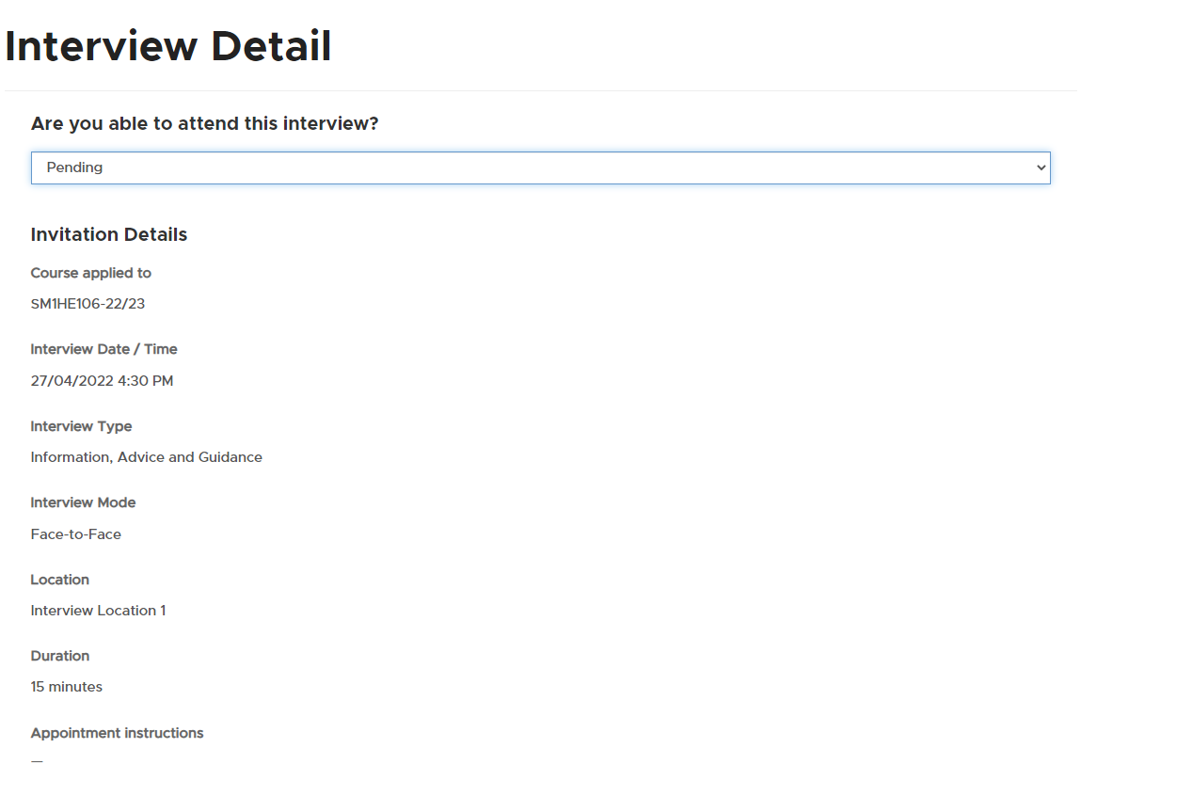

Here you can confirm attendance or decline the interview from the drop down menu under the question “Are you able to attend this interview?” this is located at the top of the page. If you wish to give details of when is best for you to attend, you can add comments at the bottom of the page in the “Do you have any comments for the tutor?” box.

How to accept your offer

Go to the menu at the top of the portal web page and click on Offers you will then be directed to the follow page. Go to the list under Offers pending acceptance, from the list choose the course that you wish to accept the offer, then next the course title on the left hand-side listed in red is the course code, click on the course.
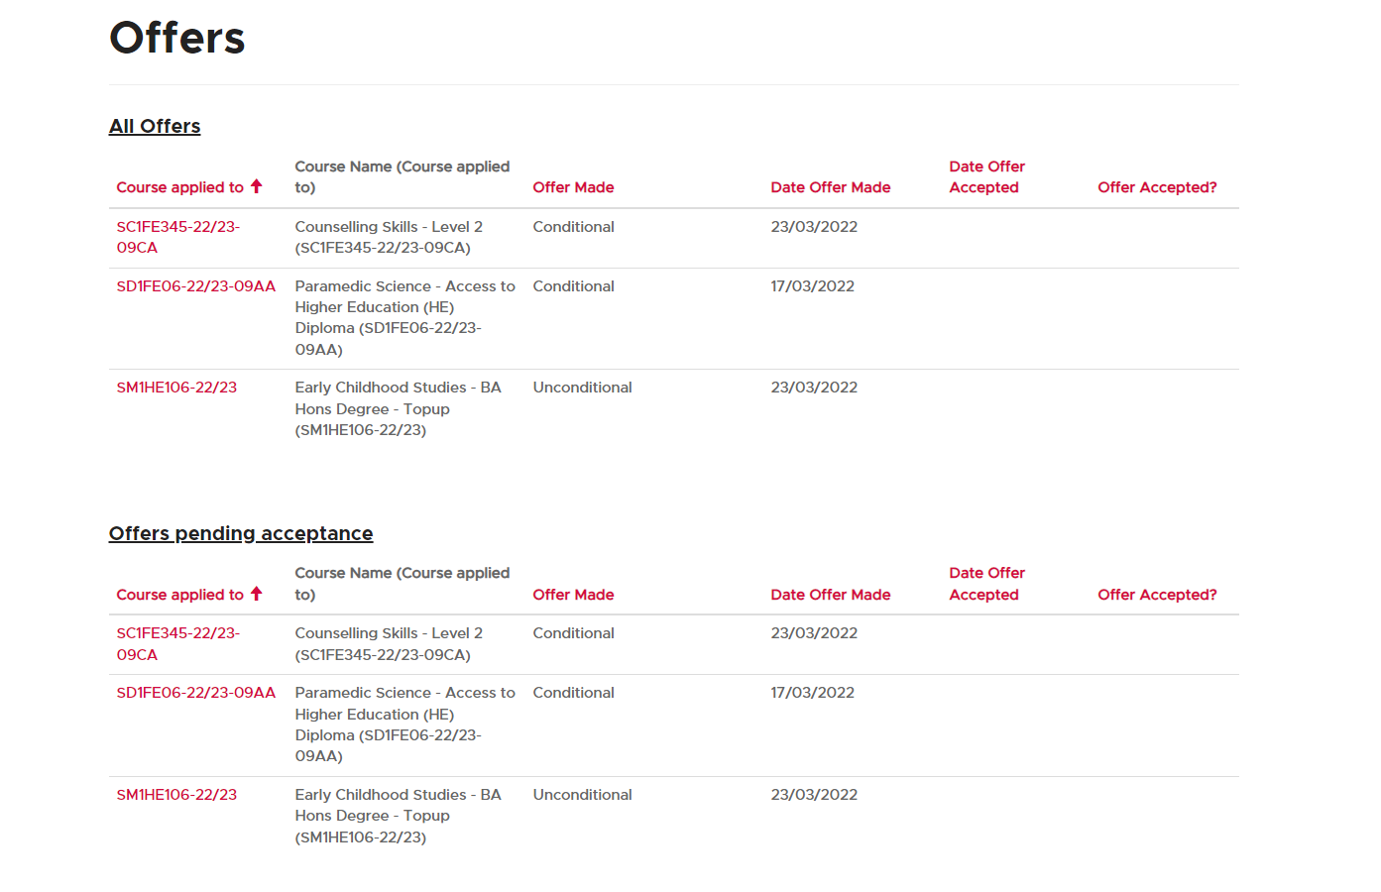

You will then be directed to the following page:
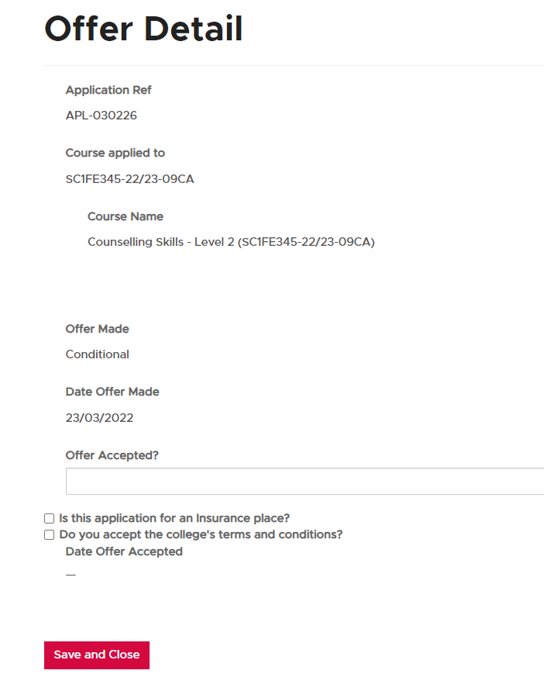

At the bottom of this page you can use the drop down menu located below Offer Accepted? to accept your offer, if this is an HE application you will also have to confirm that you have read and accepted the HE Terms and Conditions before you are able to accept your offer. When you have done this you need to save and close.

How to view and update your funding information

Go to the menu at the top of the portal web page and click on Funding you will then be directed to the follow page:
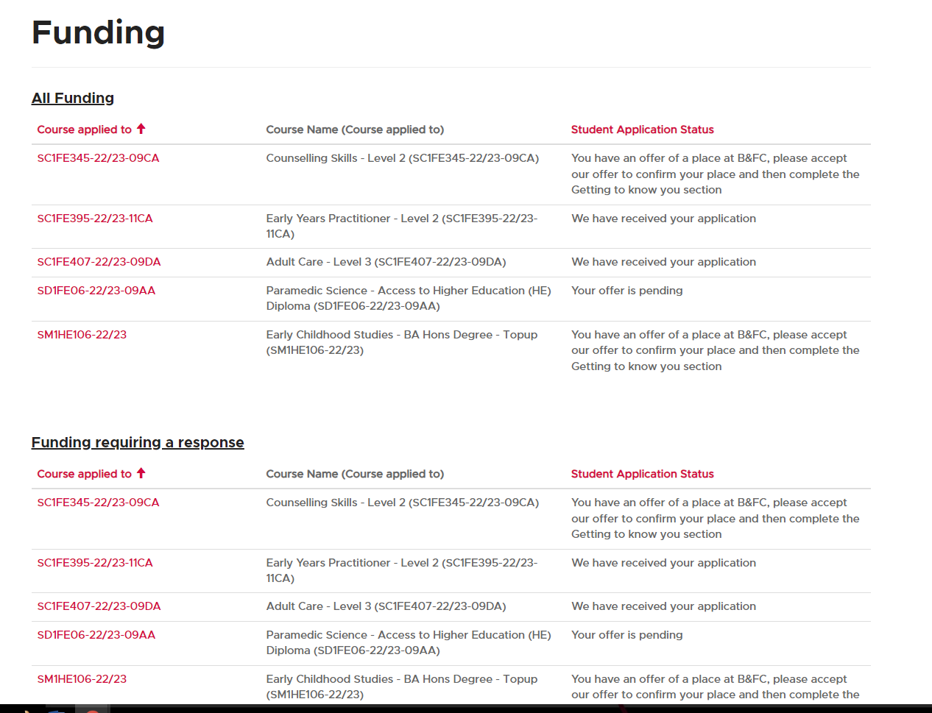
From the listing headed “Funding requiring a response”, choose the course you need to add information to by clicking on the course code on the left hand-side which is highlighted red. You will be directed to the page below, if your course is going to be funded by your employer, or via an adult learner loan you can add the details here. You can also upload your evidence here by clicking on the Add note button at the bottom of the page (see below)
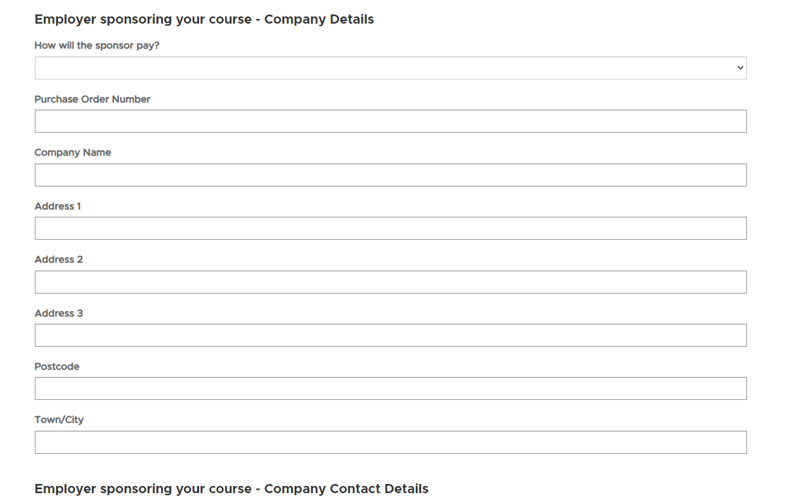
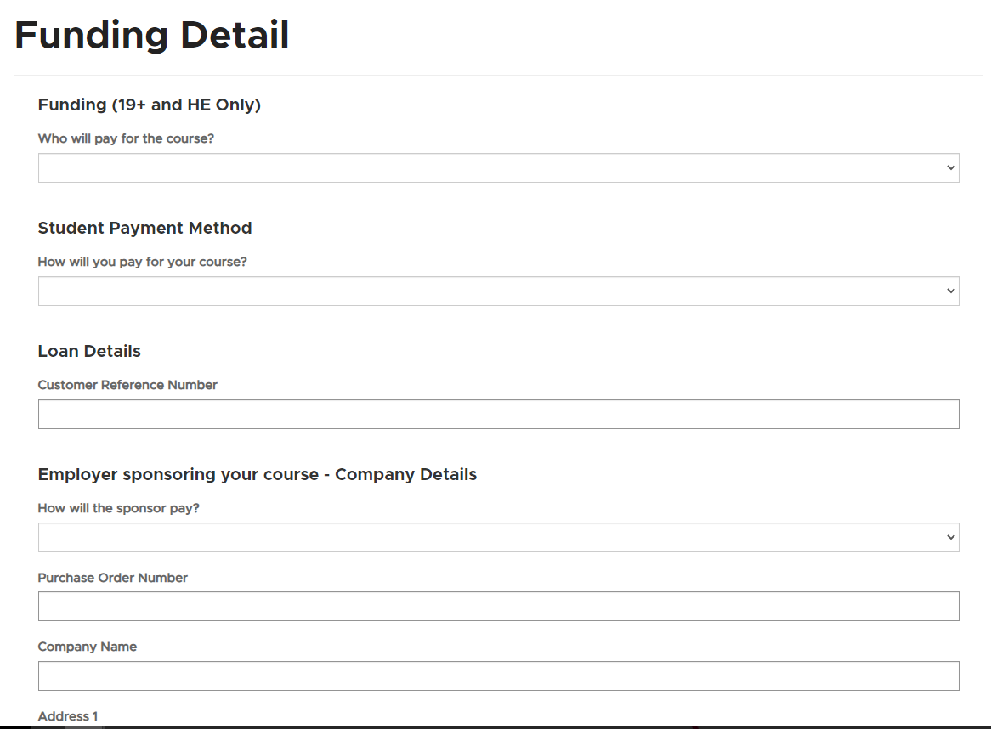

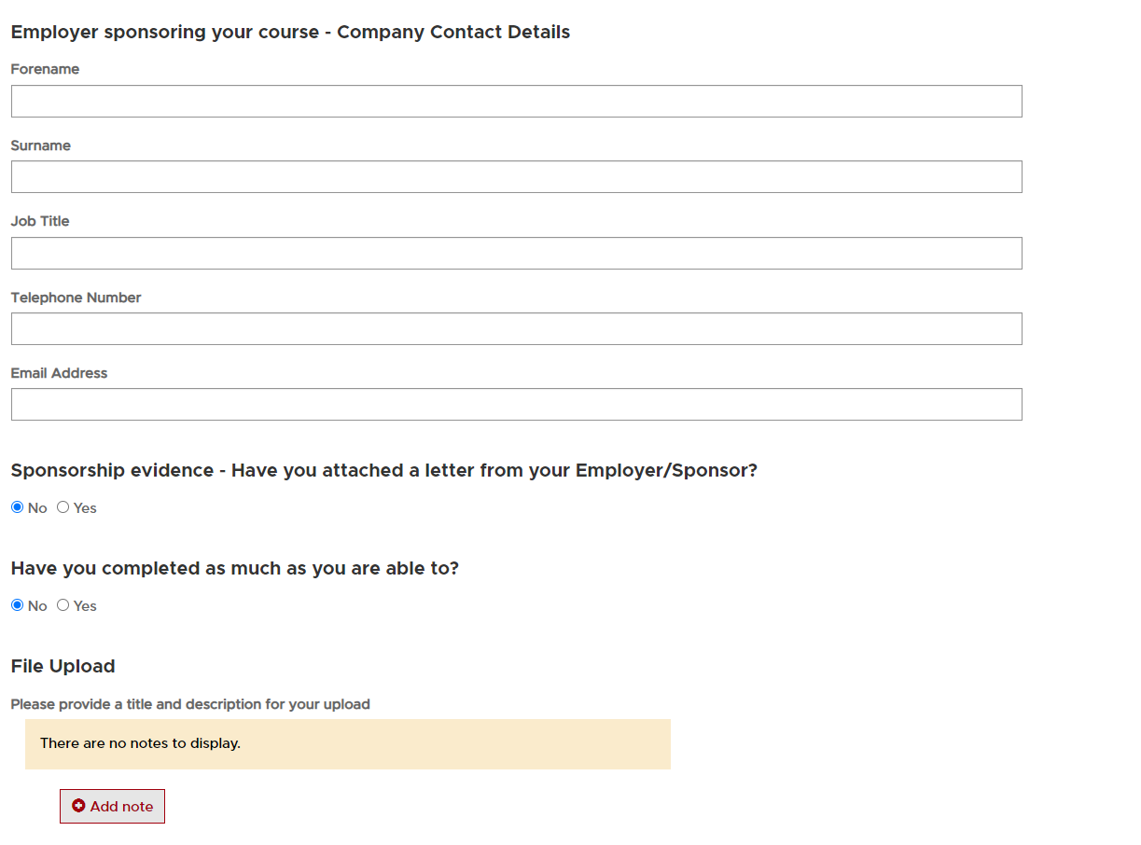
You can upload your documents by clicking on the Add note button. You will then
be directed to the following page:

Click on choose file, you will be directed to your files, click on the file you want to upload, from the file dialogue box click the open button at the bottom right of the box. You will then be directed back to the page above, click on the add note button and your file will be uploaded and will be listed in your file uploads on the Funding Details page.

How to view work placement information

Go to the menu at the top of the portal web page and click on work placemnt you will then be directed to the page below. Here you can view your work placements.
